Forklift Graduation Team Ainshams University January 15, 2023

Locating Differential Bearing



SKF Bearing Select Report 1.3-186

1. Abstract



Deep groove ball bearing

SKF Explorer

Calculation overview

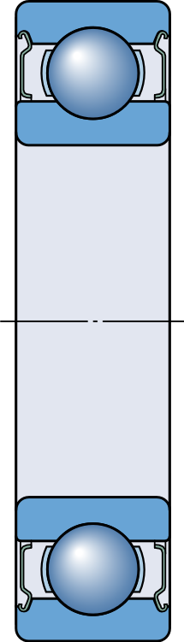



|  |  |  |  |  |  |  |  |
| --- | --- | --- | --- | --- | --- | --- | --- |
|  | Bearing | rating | life | Static safety factor | Frictional moment | Power loss |  |
| Designation | Basic | SKF life | |  | Total |  |
|  | L10h (h) | L10mh (h) | | S0 | M (Nmm) | Ploss (W) |
| [6005-2Z](https://www.skf.com/productcatalogue?language=en&system=metric&designation=6005-2Z) | 5540 | 3880 | | 1.77 | 129 | 1.4 | |

|  |
| --- |
| Consideration  All calculated values are best estimates resulting from the input data and assumptions, and well-recognized data sources, and well-established calculation methods.  SKF follows standards and methods suggested by Greenhouse Gas Protocol for CO2 estimates. For details about data, methods, and assumptions used, follow the link below.  If you intend to use these values for decision making, contact SKF for more details and correct interpretation of calculation results. The values calculated by SKF Bearing Select should not be compared with values obtained from other tools or sources, unless you are confident about the data sources, methods and assumptions used. [More info](https://skf.com/group/support/engineering-tools/bearing-select/info-about-co2-est) |
|  |
| Consideration  Grease consumption is almost zero, therefore CO2 emissions are not calculated. |
|  |
| Consideration  The calculated SKF rating life L10 mh is shorter than the period of interest. |
|  |
| Consideration  Low viscosity ratio k, reduced asperity contact. It is recommended to select a higher viscosity lubricant or improve cooling. It is not appropriate to look at basic rating life only. Instead use SKF rating life method. Recommended to use anti-wear (AW) or extreme pressure (EP) additives to reduce wear [More info](https://www.skf.com/group/products/rolling-bearings/principles-of-rolling-bearing-selection/bearing-selection-process/bearing-size/size-selection-based-on-rating-life/lubrication-condition-the-viscosity-ratio-k) |



Rotating ring Inner ring rotation

Maximum temperature is used for calculating the actual viscosity, kappa, aSKF and SKF rating life. Mean temperature is used for calculating bearing friction and power loss.

2.2. Loads, Speed and Temperature



1. Input

2.1. Bearing data

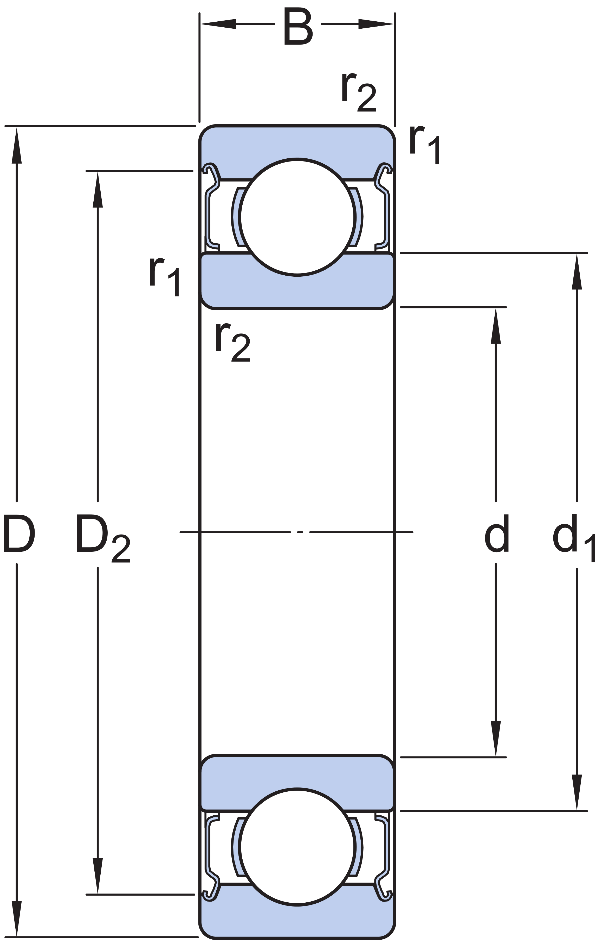

|  |  |  |  |  |  |  |  |  |  |  |
| --- | --- | --- | --- | --- | --- | --- | --- | --- | --- | --- |
|  |  | Principal | dimensions | | Basic load | ratings | Fatigue load limit | Speed ratings | | Cleara nce class |
| Designation | Bearing type |  | | | Dynamic | Static |  | Reference | Limiting |  |
|  |  | d (mm) | D (mm) | B (mm) | C (kN) | C0 (kN) | Pu (kN) | nref (r/min) | nlim (r/min) |
| [6005-2Z](https://www.skf.com/productcatalogue?language=en&system=metric&designation=6005-2Z) | Deep ball groove  bearing | 25.0 | 47.0 | 12.0 | 11.9 | 6.55 | 0.275 | 32000.0 | 16000.0 | Norma l |

|  |  |  |  |  |  |  |  |  |  |  |  |  |
| --- | --- | --- | --- | --- | --- | --- | --- | --- | --- | --- | --- | --- |
| Forces | | | | | | Speed | Temperature | | | | Case weight |  |
| Radial | | ( Fr | ) | (kN) | Axial ( Fa ) (kN) | (r/min) | Inner | ring | (°C) | Outer ring (°C) |  |
| LC1 | 3.7 | 0.0 | | | | 100.0 | 30 | 30 | | | 1 | |

|  |  |  |  |  |  |  |  |  |
| --- | --- | --- | --- | --- | --- | --- | --- | --- |
| 2.3. Lubrication | | | | | | | | |
|  |  |  | Lubricant | Effective EP additives | Contamination | |  |  |
| Designation | Name |  | Method | Cleanliness / Factor |
|  | [6005-2Z](https://www.skf.com/productcatalogue?language=en&system=metric&designation=6005-2Z) | | MT47 | False | Detailed guidelines | High cleanliness | |  |
|  |  | | | | | | |  |



3.2. Bearing minimum load



3.3. Adjusted reference speed

|  |  |  |  |  |  |  |
| --- | --- | --- | --- | --- | --- | --- |
| 2.4. CO2 emissions settings | | | | | | |
|  | Designation | Input energy mix manually | Geographical location | Period of interest [Years] | Time operational [%] |  |
|  | [6005-2Z](https://www.skf.com//opcprodlink.html?lang=language_Report&imperial=metric&prodid=6005-2Z) | False | European Union | 1 | 100 |  |
|  |  | | | | |  |

|  |  |  |  |  |  |  |  |  |  |
| --- | --- | --- | --- | --- | --- | --- | --- | --- | --- |
| 2.5. Fits and tolerances | | | | | | | | | |
|  |  |  | Requirements | Tolerance | Class | Calculated interference | Include Smoothing |  |  |
| Designation | Guidance | Housing | Shaft |  |  |
|  | [6005-2Z](https://www.skf.com/productcatalogue?language=en&system=metric&designation) | | False | G7 | g6 | True | True | |  |
|  |  | | | | | | | |  |

1. Results



|  |  |  |  |  |  |  |  |  |  |
| --- | --- | --- | --- | --- | --- | --- | --- | --- | --- |
| 3.1. Loads & static safety | | | | | | | | | |
|  |  |  | Load | ratio | Static safety factor | Equivalent dynamic load | Equivalent static load |  |  |
| Designation | C/P | S0 | | P (kN) | P0 (kN) |
|  | [6005-2Z](https://www.skf.com/productcatalogue?language=en&system=metric&designation=6005-2Z) | | 3.22 | 1.77 | | 3.7 | 3.7 | |  |
|  |  | | | | | | | |  |

|  |  |  |  |  |  |  |
| --- | --- | --- | --- | --- | --- | --- |
|  |  | Reaction | forces Minimum load | |  |  |
| Designation | Radial | Axial | | Requirements |
|  | Fr (kN) | Fa (kN) | Frm (kN) | met? |
| [6005-2Z](https://www.skf.com/productcatalogue?language=en&system=metric&designation=6005-2Z) | | 3.7 | 0.0 | 0.0177 | yes | |

|  |  |  |  |  |  |  |  |
| --- | --- | --- | --- | --- | --- | --- | --- |
|  |  | Adjusted reference speed | Adjustment | factors | | |  |
| Designation |  | For bearing | load | P | For oil viscosity |
|  | nar (r/min) | fp | fv | | |
| [6005-2Z](https://www.skf.com/productcatalogue?language=en&system=metric&designation=6005-2Z) | | 13700 | 0.41 | 1.03 | | | |



3.4. Lubrication conditions



3.5. Bearing rating life



3.7. Bearing frequencies

|  |  |  |  |  |  |  |  |  |  |  |  |
| --- | --- | --- | --- | --- | --- | --- | --- | --- | --- | --- | --- |
|  |  | Frictional moment Friction sources | | | | | | | | Power loss |  |
| Designation | Total | At start and 20-30°C  zero speed | | Rolling | Sliding | Seals |  | Drag loss |  |
|  | M (Nmm) | Mstart | (Nmm) | Mrr (Nmm) | Msl (Nmm) | Mseal | (Nmm) | Mdrag (Nmm) | Ploss (W) |
| [6005-2Z](https://www.skf.com/productcatalogue?language=en&system=metric&designation=6005-2Z) | | 129 | 195 | 11.1 | | 118 | 0 | 0 | | 1.4 | |

|  |  |  |  |  |  |  |
| --- | --- | --- | --- | --- | --- | --- |
|  |  | Operating viscosity | | | Viscosity ratio |  |
| Designation | Actual | Rated | Rated @ 40 °C |  |
|  | ν (mm^2/s) | ν1 (mm^2/s) | νref (mm^2/s) | κ |
| [6005-2Z](https://www.skf.com/productcatalogue?language=en&system=metric&designation=6005-2Z) | | 128 | 147 | 85.0 | 0.87 | |

|  |  |  |  |  |  |  |  |
| --- | --- | --- | --- | --- | --- | --- | --- |
|  |  | Bearing | rating | life | SKF life modification factor | Contamination factor |  |
| Designation | Basic | SKF | |  |  |
|  | L10h (h) | L10mh (h) | | askf | ηc |
| [6005-2Z](https://www.skf.com/productcatalogue?language=en&system=metric&designation=6005-2Z) | | 5540 | 3880 | | 0.7 | 0.45 | |

|  |
| --- |
| Consideration  Low viscosity ratio k, reduced asperity contact. It is recommended to select a higher viscosity lubricant or improve cooling. It is not appropriate to look at basic rating life only. Instead use SKF rating life method. Recommended to use anti-wear (AW) or extreme pressure (EP) additives to reduce wear [More info](https://www.skf.com/group/products/rolling-bearings/principles-of-rolling-bearing-selection/bearing-selection-process/bearing-size/size-selection-based-on-rating-life/lubrication-condition-the-viscosity-ratio-k) |
|  |
| 3.6. Bearing friction & power loss |
|  |

|  |  |  |  |  |  |  |  |  |  |  |  |
| --- | --- | --- | --- | --- | --- | --- | --- | --- | --- | --- | --- |
|  | Rotational frequencies | | | | | | | Frequency of over-rolling | | | |
| Designation | Inner | ring | Outer ring | Rolling & cage | element | set | Rolling element about its axis | Point on inner ring | Point on outer ring | Rolling | element |
|  | fi (Hz) | fe (Hz) | | fc (Hz) | fr (Hz) | | | fip (Hz) | fep (Hz) | frp (Hz) | |
| [6005-2Z](https://www.skf.com/productcatalogue?language=en&system=metric&designation=6005-2Z) | 1.667 | 0.0 | | 0.677 | 4.29 | | | 9.895 | 6.772 | 8.58 | |



* Value is not designation specific, but based on bearing mass

3.8. Estimation of CO2 emissions over period of interest

|  |  |  |  |  |  |  |  |  |  |  |  |
| --- | --- | --- | --- | --- | --- | --- | --- | --- | --- | --- | --- |
|  | Shaft outer | diameter | Bearing bore | | Bearing outer diameter | | Housing bore | | Smoothing | | |
| Designation | Minimum | Maximum | Minimum | Maximum | Minimum | Maximum | Minimum | Maximum | Shaft an bearing | d bore | Bearing outer ring and housing |
|  | (μm) | (μm) | (μm) | (μm) | (μm) | (μm) | (μm) | (μm) | (μm) | (μm) | |
| [6005-2Z](https://www.skf.com/productcatalogue?language=en&system=metric&designation=6005-2Z) | -20 | -7 | -10 | 0 | -11 | 0 | 9 | 34 | 7 | 12 | |

|  |  |  |  |  |  |  |  |  |  |
| --- | --- | --- | --- | --- | --- | --- | --- | --- | --- |
|  |  | CO2 emissions caused by bearing production | CO2 emissions during bearing operation - over period of interest | | | | Resources consumed during bearing operation - over period of interest | |  |
| Designation |  | Frictio power | nal loss | Grease c onsumpt ion | Sum of CO2 o  during  peration | Energy | Grease |
|  | kg of CO2 | kg of | CO2 | kg of  CO2 | kg of  CO2 | kWh | kg |
| [6005-2Z](https://www.skf.com/productcatalogue?language=en&system=metric&designation=6005-2Z) | | [*0.3 (Learn more)](https://skf.com/group/support/engineering-tools/bearing-select/info-about-co2-est#cid-596137) | 5.5 | 0.0 | | 5.5 | 11.9 | 0.0 | |

|  |  |  |
| --- | --- | --- |
| Consideration  All calculated values are best estimates resulting from the input data and assumptions, and well-recognized data sources, and well-established calculation methods.  SKF follows standards and methods suggested by Greenhouse Gas Protocol for CO2 estimates. For details about data, methods, and assumptions used, follow the link below.  If you intend to use these values for decision making, contact SKF for more details and correct interpretation of calculation results. The values calculated by SKF Bearing Select should not be compared with values obtained from other tools or sources, unless you are confident about the data sources, methods and assumptions used. [More info](https://skf.com/group/support/engineering-tools/bearing-select/info-about-co2-est) | | |
|  | | |
| Consideration  Grease consumption is almost zero, therefore CO2 emissions are not calculated. | | |
|  | | |
| Consideration  The calculated SKF rating life L10 mh is shorter than the period of interest. | | |
|  | | |
| 3.9. Fits and tolerances | | |
|  | Note  Typically, it is not sufficient to use an interference fit alone to axially locate a bearing ring on a cylindrical seat. |  |
| 3.9.1. Tolerances | | |
| Consideration  For the tolerances calculation, the normal tolerance for the bearing bore and outer diameter is used. | | |



3.9.2. Fits, Probable Interference (+) / Clearance (-)

|  |  |  |  |  |  |  |  |  |
| --- | --- | --- | --- | --- | --- | --- | --- | --- |
|  |  | Shaft | | | Housing | | |  |
| Designation | Probable minimum | Middle | Probable maximum | Probable minimum | Middle | Probable maximum |
|  | (μm) | (μm) | (μm) | (μm) | (μm) | (μm) |
| [6005-2Z](https://www.skf.com/productcatalogue?language=en&system=metric&designation=6005-2Z) | | -24 | -16 | -7 | -53 | -39 | -25 | |

SKF Bearing Select 6 2023-01-15 16:31:43

LIMITED WARRANTY : The SKF Bearing Select software tool of the SKF Company supports the calculation and selection of bearings.

This software is provided 'as is' with out any warranty of any sort, implicitly as well as explicitly.

Please note that the obtained results can be affected by many external parameters and/or the quality of the assumptions taken into account. The results obtained using this software must be validated by the user who accepts the fact that the use of this software and the exploitation of the obtained results are under the user's entire and sole responsibility.

® SKF is a registered trademark of the SKF Group. © SKF Group 2022.